*2026 General Student Application Form*

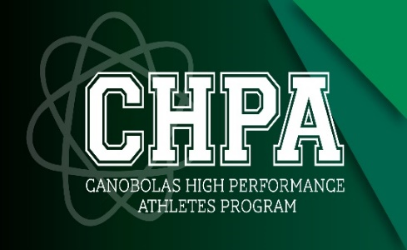

*“An athlete is a normal person with a gift and a desire to overcome challenges to achieve greatness. How we accept the challenge and attack the challenge head-on is only about us; no one can touch that. If we win or lose this weekend, it will not make a difference in our lives. But why we play and how we play will make a difference in our lives forever."*

Dear Student / Parent / Caregiver,

Thank you for your interest in the **Canobolas High-Performance Athlete (CHPA) program**. Students participating in the CHPA program currently undertake specialised athlete development programs delivered at school throughout the week. This program provides support to a full academic curriculum but caters for the special needs of talented pre-elite athletes and dancers.

#### PLACEMENT IN THE PROGRAM IS DEPENDENT ON:

* An ability, interest and potential in a nominated sport or athletic domain.
* Satisfying high levels in attitude, work habits and respectful and responsible behaviour.

#### CONTINUATION IN THE PROGRAM IS DEPENDENT ON:

* A high level of engagement in the program, including training sessions and school-based events.
* Development and improvement in the nominated sport and/or athletic or physical performance.
* Satisfactory academic performance and acceptable levels of attendance (85%) in class and the CHPA program itself.
* Continued demonstration of respectful and responsible behaviour.

Please note the following sequence is required to gain placement in the program:

1. Complete the ‘**Canobolas High-Performance Athletes Application Form**’ (sections A-C)
2. Attach full **copies** of the two most recent school reports.
3. A **letter of support** from your representative or academy coach or private dance teacher. A referral from your classroom teacher is insufficient.

#### (DO NOT ATTACH ORIGINALS)

#### Hand these back to the school administration

* Successful and unsuccessful applicants will be advised in writing. This process can take up to 4 weeks from the closing date of nominations.
* Please ensure the information you are submitting is true and correct. If it is found to be false or misleading, any offer for placement may be withdrawn. All information is treated with the strictest confidence.

**PLEASE READ CAREFULLY, COMPLETE AND   
RETURN THE FOLLOWING DOCUMENTS**

Please return the application to:

Canobolas Rural Technology School administration no later than:

**Friday 17th October 2025**

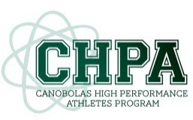**Canobolas High-Performance Athletes (CHPA)**

*2026 General Student Application Form*

**SECTION A**

|  |  |  |  |  |  |  |  |  |  |  |
| --- | --- | --- | --- | --- | --- | --- | --- | --- | --- | --- |
| **Full Name:** |  | | **Age:** | |  | **DOB:** |  | | **Gender:** |  |
| **Phone (HM)** |  | | **Emergency Contact Name:** | | | | |  | | |
| **Postal Address:** | |  | | | | **EC Number:** | |  | | |
| **Students Preferred Email:** | |  | | | **Parents Preferred Email:** | |  | | | |
| **Nominated sports, dance or athletic domain:** | | | |  | | | | | | |

|  |  |  |  |  |
| --- | --- | --- | --- | --- |
| **Current School:** |  | | **Year:** |  |
| **Aboriginal and/or Torres Strait Islander:** | | **YES: Aboriginal [ ] Torres Strait Islander [ ] Both [ ]  NO [ ]** | | |

#### SCHOOL REPRESENTATION:

Successful applicants will be required to represent Canobolas Rural Technology High School, Western Area, and NSW Combined High Schools in ANY sporting activity for which they are selected. Whilst a condition of selection to CHPA is that students make themselves available for Sporting Association / Club programs and CHPA-programmed events, everyone’s commitments will be monitored and discussed with students and parents.

**It is compulsory that CHPA students compete to the best of their ability at school Athletic and Swimming Carnivals and regional Cross Country.**

#### MEDICAL CONDITION:

To the best of my knowledge, the student applying has no long-term medical condition, physical disability or injury which puts him/her at risk when participating in the school's CHPA program.

**ATTENTION**

**Program participation is subject to behaviour, effort and attitude in all school activities.   
Participants may be removed from the program at the discretion of the CHPA director and the school principal.**

**I state that I wish to participate in programmed activities.**

|  |  |  |  |
| --- | --- | --- | --- |
| Parent / Carer Signature: |  | Student Signature: |  |
| Date: |  | Date: |  |

**Canobolas High Performance Athletes (CHPA)**

*Student Information Form*

**SECTION B**

|  |  |  |  |
| --- | --- | --- | --- |
| **Student Name:** |  | **Student’s Main Sport** |  |

**Summarise your major sporting, dance or athletic achievements.**

|  |
| --- |
|  |
|  |
|  |
|  |
|  |
|  |

**List any current qualifications or certificates you have that would be relevant to your inclusion in the CHPA program.**

|  |
| --- |
|  |
|  |
|  |

**Circle the most appropriate response.**

|  |  |  |  |
| --- | --- | --- | --- |
| **SCHOOL SATISFACTION:** | Enjoying school | Ok but here because I must be | Not enjoying school |
| **ACADEMIC ACHIEVEMENT:** | Towards the top of my classes | Somewhere in the middle of my classes | Struggling with the demands of  schoolwork |
| **SCHOOL INVOLVEMENT:** | Involved in many aspects of school life. | I do a couple of extra activities at school | I do nothing extra now, just my classes |
| **UNIFORM:** | Wear it with pride all of  the time | Usually wear it | Sometimes I choose  not to wear my uniform. |

**List any other extra-curricular activities you are currently involved in at school or in the community   
(i.e. band, debating, paid work, coaching)**

|  |
| --- |
|  |
|  |
|  |

**Briefly outline some goals you have for the future.**

|  |  |  |
| --- | --- | --- |
| **6 Months** | **12 Months** | **2 Years** |
|  |  |  |

Please **circle**:

* I am **a confident / not a confident** swimmer; and can swim approx. ___________________ without a break.
* I own or have access to a suitable and reliable bike for road and/or off-road riding and a helmet

**Yes / No** Bike types _____________________________________________________________________

### **In my opinion, I believe I would benefit from being a member of Canobolas High Performance Athletes Program because: (Please write a statement below to support your own application)**

|  |
| --- |
|  |
|  |
|  |
|  |
|  |
|  |
|  |
|  |
|  |
|  |
|  |

|  |  |  |  |
| --- | --- | --- | --- |
| Student Signature: |  | Date: |  |

***REQUIRED DOCUMENTATION WITH APPLICATION***

1. Full **copies** of the two most recent school reports.
2. A **letter of support** from your representative or academy coach or private dance teacher.
3. The attached **school assessment form is** to be completed by your teacher.
4. For Dance applicants - a link to an audition video or USB with the video. For further instructions, see attached sheet on Dance audition information.

**Canobolas High Performance Athletes (CHPA)**

*School Assessment Form*

***Teacher***

**SECTION C**

|  |  |  |  |
| --- | --- | --- | --- |
| **Student Name:** |  | **Student’s Main Sport** |  |

|  |  |  |  |
| --- | --- | --- | --- |
| **Teacher’s Name:** |  | **School:** |  |

**CLASSROOM TEACHER’S RECOMMENDATION**

(Teachers need to comment on FOUR aspects – attendance, attitude, behaviour and effort).

|  |
| --- |
|  |
|  |
|  |
|  |
|  |

**Circle the appropriate description for the student.**

|  |  |  |  |
| --- | --- | --- | --- |
| **GENERAL**  **BEHAVIOUR:** | Respectful & well  mannered | Needs reminding to  stay on task | Disruptive |
| **PUNCTUALITY:** | Always on time | Usually on time | Regularly late |
| **ATTITUDE:** | Cooperative (always) | Cooperative (usually) | Cooperative (rarely) |
| **UNIFORM:** | Always | Usually | Sometimes |

In my professional opinion, I believe **would / would not** benefit from regular involvement in the High-Performance Athlete Program as part of his/her current curriculum structure.

**Please comment on student suitability:**

|  |
| --- |
|  |
|  |
|  |

|  |  |  |  |
| --- | --- | --- | --- |
| Teacher Signature: |  | Date: |  |

**Canobolas High Performance Athletes (CHPA)**

*Dance Audition Information*

All dance applicants must submit a video audition of a solo sequence/dance of 1-2 minutes in their chosen genre of dance (e.g. Ballet, Modern, Contemporary, Tap, Jazz, Hip-Hop). You can submit the audition via USB or as per the instructions below.

**IMPORTANT:** Successful applicants must be able to commit to rehearsals 1-2 times a week before school, from 8 am. They are expected to participate in dance techniques and learn routines for various events/eisteddfods.

**How to Upload Footage to YouTube**

## Go to [www.youtube.com](http://www.youtube.com/) and click **‘Sign In’**



1. **‘Sign in’** or **‘Create an Account’** if you don’t already have one

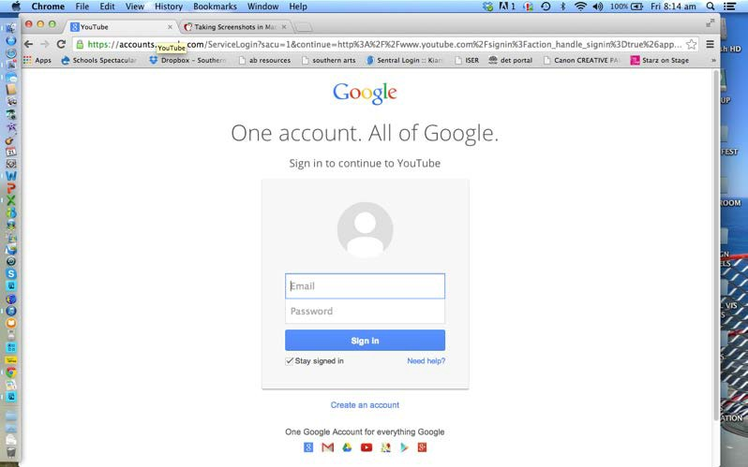

1. Select **‘upload’**



1. Follow the instructions on screen to upload your video.
2. Once uploaded, on the privacy settings select **“unlisted”** (anyone with the link can view)’. This is important as selecting this setting means that the general public can’t view the link. Once you have done this, ensure you select **‘Save Changes’**. **Do not select “Private”.**
3. When this is finished, you will be given a URL for your video.
4. Copy this URL and send it via email to: [michelle.somers2@det.nsw.edu.au](mailto:michelle.somers2@det.nsw.edu.au)
5. In your email, please use the subject title - CHPA Dance Application 2026.